Style Sheet Language

🎨 What is a Style Sheet Language?
# Source: AI Source: Provided by: [Data Path: Persons Table -> ID Column: 1, Name_En Column: Motasem Essam] -> From: [Chatgpt (GPT‑5 Mini)] on [1/26/2026]
A style sheet language is a computer language used to describe the presentation (visual formatting and layout) of structured documents, such as HTML or XML.
🧠 In short: It tells the browser how things should look, not what they are.

🧩 Key Characteristics
# Source: AI Source: Provided by: [Data Path: Persons Table -> ID Column: 1, Name_En Column: Motasem Essam] -> From: [Chatgpt (GPT‑5 Mini)] on [1/26/2026]
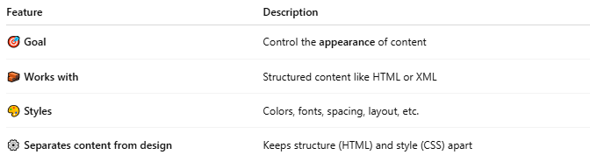

Feature | Description
🎯 Goal | Control the appearance of content
🧱 Works with | Structured content like HTML or XML
🎨 Styles | Colors, fonts, spacing, layout, etc.
⚙️ Separates content from design | Keeps structure (HTML) and style (CSS) apart

💡 Example (HTML + Style Sheet)
# Source: AI Source: Provided by: [Data Path: Persons Table -> ID Column: 1, Name_En Column: Motasem Essam] -> From: [Chatgpt (GPT‑5 Mini)] on [1/26/2026]
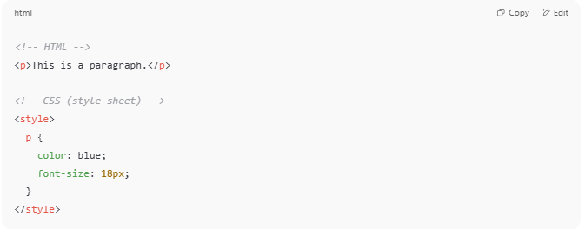

<!-- HTML -->
<p>This is a paragraph.</p>

<!-- CSS (style sheet) -->
<style>
p {
color: blue;
font-size: 18px;
}
</style>

✅ The paragraph is shown in blue, size 18px

🔍 Popular Style Sheet Languages
# Source: AI Source: Provided by: [Data Path: Persons Table -> ID Column: 1, Name_En Column: Motasem Essam] -> From: [Chatgpt (GPT‑5 Mini)] on [1/26/2026]
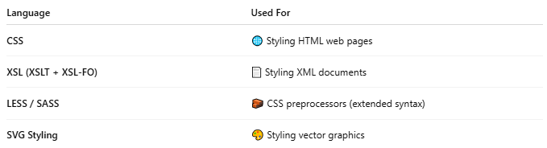

Language | Used For
CSS | 🌐 Styling HTML web pages
XSL (XSLT + XSL-FO) | 📄 Styling XML documents
LESS / SASS | 🧱 CSS preprocessors (extended syntax)
SVG Styling | 🎨 Styling vector graphics

✅ Benefits of Style Sheet Languages
# Source: AI Source: Provided by: [Data Path: Persons Table -> ID Column: 1, Name_En Column: Motasem Essam] -> From: [Chatgpt (GPT‑5 Mini)] on [1/26/2026]
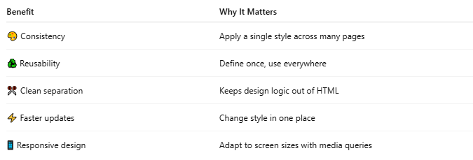

Benefit | Why It Matters
🎨 Consistency | Apply a single style across many pages
♻️ Reusability | Define once, use everywhere
✂️ Clean separation | Keeps design logic out of HTML
⚡ Faster updates | Change style in one place
📱 Responsive design | Adapt to screen sizes with media queries

📌 Summary
# Source: AI Source: Provided by: [Data Path: Persons Table -> ID Column: 1, Name_En Column: Motasem Essam] -> From: [Chatgpt (GPT‑5 Mini)] on [1/26/2026]
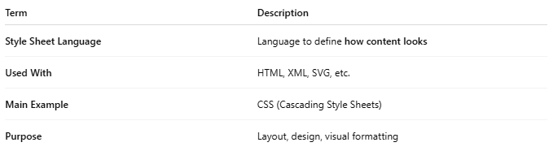
Term | Description
Style Sheet Language | Language to define how content looks
Used With | HTML, XML, SVG, etc.
Main Example | CSS (Cascading Style Sheets)
Purpose | Layout, design, visual formatting

